# Scrum Tools – A comparative study

**Version One**:

1. It’s a paid Agile management tool.
2. The trial period consists of 30 days only.
3. Supports online use capability/
4. Supports Scrum, Kanban methodologies.
5. Supports integration with JIRA.

**Rally**:

1. Also, a paid tool.
2. Demo period free for 30 days.
3. Supports online use capability.

**TFS**:

1. It’s a Microsoft product in line with Visual Studio.
2. With Visual Studio account, we get 5 **FREE** Basic user licenses
3. I have created my account here to test the tool and it does take time to get through the functionalities.
4. We can have 5 members in this tool.
5. Please find below screenshot:

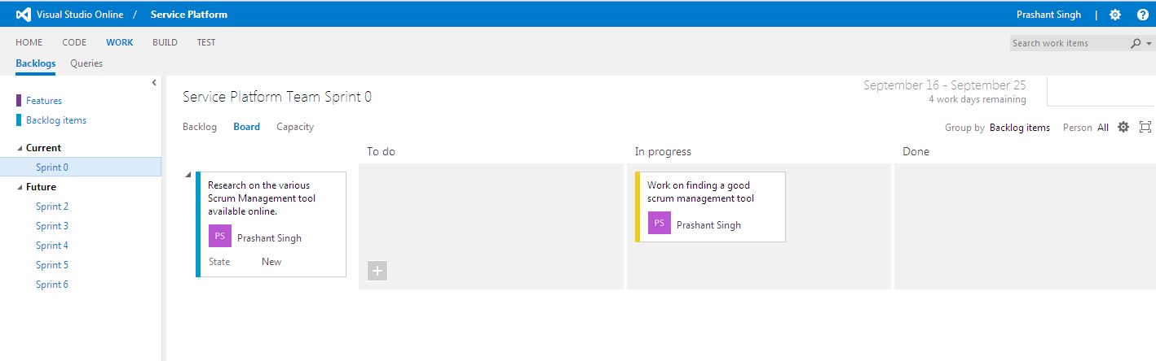

1. For more on this and its use as Scrum tool, Team can further read about its features [here](https://msdn.microsoft.com/en-us/magazine/dn189203.aspx).

**Scrum Desk**:

1. This is a free for web, online Scrum management tool, with no limitations.
2. For trying, I have already created the project dashboard and have invited Sunil Gupta for further testing & review.
3. It comes equipped with JIRA-like easy to use features: Backlog, Plan, Work, Retro & Reports.
4. I have already created project dashboard to try its features.
5. Below is a sample screenshot:

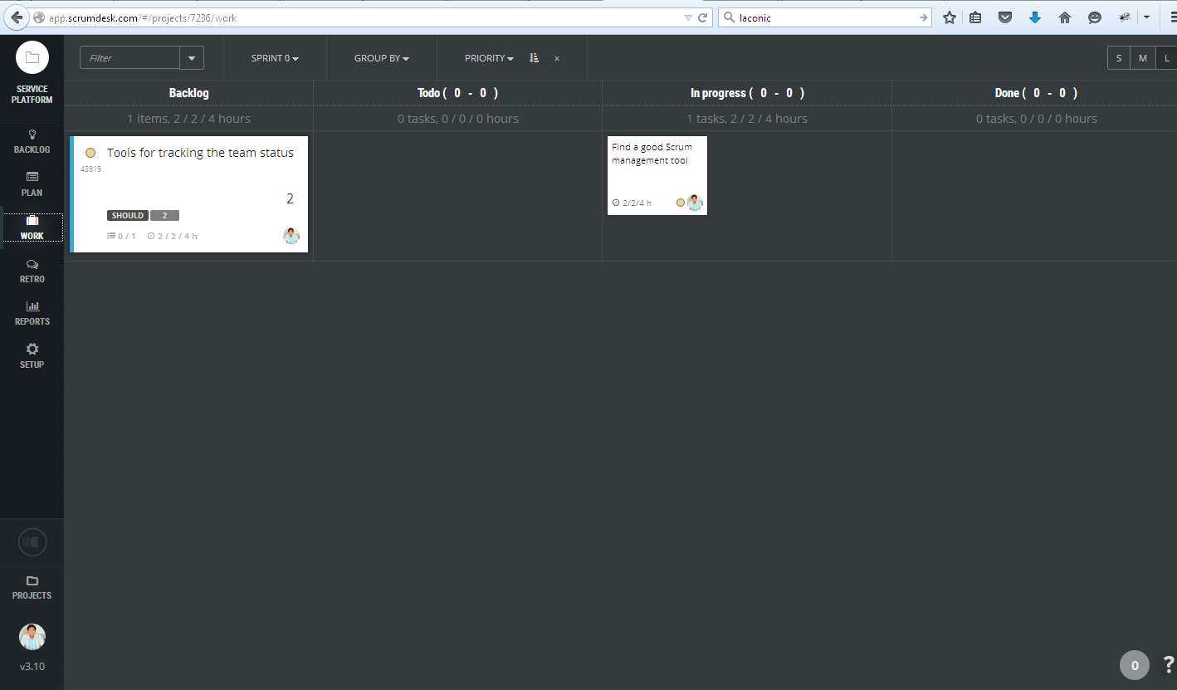

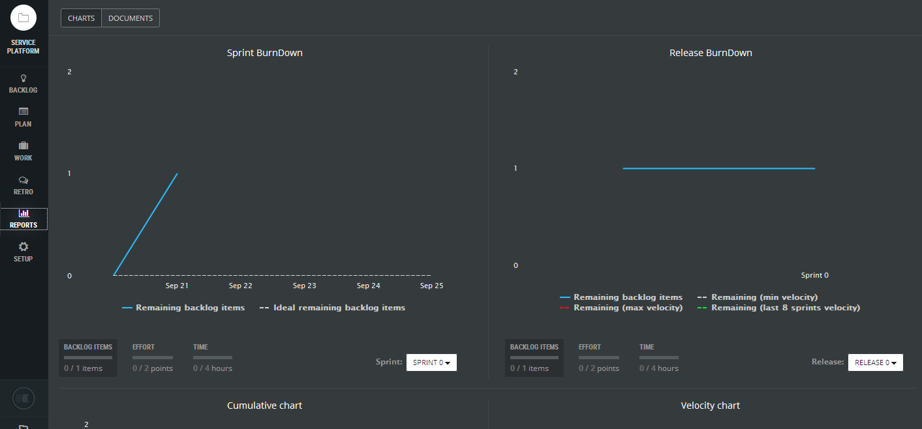

Team member Ajay’s suggestion:

we can have more solution in which we can create trial instance on Jira which will be valid for 7 days.Now after 7 days we can export all the data from current environment and will create a new instance and import all the data to this instance.

Though it’s not a good solution but still just in case if it useful.